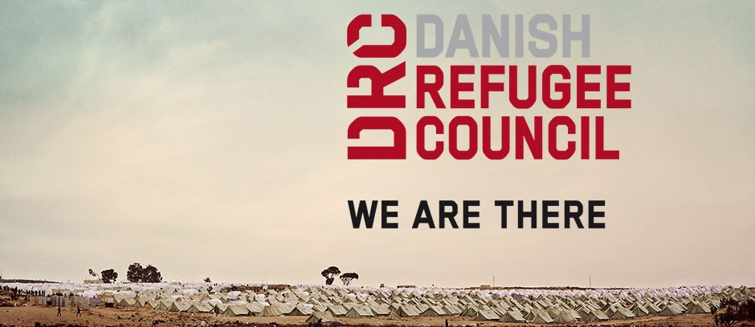

Livelihoods Manager
Damascus, Syria

The Danish Refugee Council assists refugees and internally displaced persons across the globe: we provide emergency aid, fight for their rights, and strengthen their opportunity for a brighter future. We work in conflict-affected areas, along the displacement routes, and in the countries where refugees settle. In cooperation with local communities, we strive for responsible and sustainable solutions. We work toward successful integration and – whenever possible – for the fulfilment of the wish to return home.
The Danish Refugee Council was founded in Denmark in 1956, and has since grown to become an international humanitarian organization with more than 7,000 staff and 8,000 volunteers. Our vision is a dignified life for all displaced.
All of our efforts are based on our value compass: humanity, respect, independence and neutrality, participation, and honesty and transparency.
DRC Syria
DRC has been actively operating in Syria since 2008 mainly supporting refugees. In June 2012, DRC was authorized by the Syrian Ministry of Foreign Affairs (MoFA) to expand its humanitarian efforts and provide assistance to IDPs and the vulnerable resident population countrywide. Since then, DRC activities have been focused on NFI distributions, Shelter, WASH, Protection, Education, Livelihoods and Mine Risk Education in six Governorates (Damascus, Rural Damascus, Dara'a, Aleppo, Hama, and Homs). While Protection/community service activities are provided to beneficiaries throughout our six Community Centers.

About the job
The Livelihoods Programme Manager is responsible for the development of a livelihoods strategy, operational and programmatic leadership, planning, and implementation and reporting of DRC Syria’s Livelihood portfolio including: livelihood counselling, vocational training, internships, productive workshops, asset replacements and micro-grants.
Provide thorough programmatic and operational oversight for the programme, implemented in DRC community centres, livelihoods facilities, and partner facilities and manage existing Livelihoods partnerships with key governmental and non-governmental stakeholders ties as well as explore new partnerships as needed.

Your main duties and responsibilities will be:

Strategic vision
- Develop the livelihoods strategy for DRC Syria based on the 2018 lessons learned, research findings and an analysis of the evolving context;
- Lead the implementation of the livelihoods strategy, including through the development and management of partnerships with key stakeholders including public and private sector actors.

Programme management & activities implementation
- Ensure compliance with donor and DRC rules and regulations;
- Create, refine and execute work plans, spending plans and related systems to ensure that project deadlines are met and targets achieved;
- Oversee annual, monthly and weekly implementation plan development with team members;
- Oversee the development of organizational and technical standard operating procedures, training materials for DRC Livelihood staff;
- Coordinate with programmatic colleagues to ensure joint use of facilities, approach to HR/field staff, and joint programme improvement initiatives are aligned;
- Coordinate with and ensure support from operational functions including Finance, Logistics, HR, Safety, IT, Communications, and Administration.

Monitoring, Evaluation & Learning (in coordination with the MEL Manager)
- Systematize monitoring systems to ensure reporting, internal learning and appropriate programmatic adjustments;
- Co-lead with MEAL team the development of Evidence Building Plans for Technical Programmes and for new projects.

Team Management
- Maintain and develop a Livelihoods team which is ‘fit for purpose’, and ensures duty of care to field staff;
- Recruit, capacity build/train, and mentor programme staff according to the Livelihoods competency framework;
- Provide leadership, guidance, and support to the DRC’s livelihoods staff through regular supervision and feedback on performance;
- Undertake, document and follow up performance evaluation for all staff under her/his supervision and within the wider LLH team.

Grants management & reporting
- Participate in the production of grant deliverables (narrative reports, results trackers, BFU justifications) in coordination with the Head of Programme, Grant Managers, MEL Manager, Operational teams, and Regional Livelihood Advisor.

Coordination & Representation
- Promote relations and coordinate activities with other humanitarian actors, donors, UN, civil authorities, the Syrian Arab Red Crescent (SARC), and private sector actors;
- Establish and maintain relationships with other NGOs, international organizations, government offices, particularly those working in Livelihoods;
- Actively participate in coordination mechanisms with network partners to ensure information sharing, coordination of interventions and enable meaningful intervention.

About you
To be successful in this role we expect the following:

Required
- Bachelor degree in a relevant area (social sciences, economics, or similar)
- Over five years of progressively responsible professional experience with an international NGO in strategy development, programme design, implementation, monitoring and evaluation and donor liaison;
- Minimum of three years of Livelihood programming experience;
- Solid experience in staff management in a cross-cultural environment;
- Proficiency of the English language

- A capacity building and systematic approach, to ensure sustainability of the team and programme in the longer term;
- Demonstrated training and facilitation experience;
- Experience in complex emergencies and the ability to live and work in a restricted environment, in at times stressful working conditions.

Desirable

- Master degree in International Development or similar
- Two years of recent experience in Middle-East
- Experience with European donors
- Good command of the Arabic language

In this position, you are expected to demonstrate DRC’ five core competencies:
Striving for excellence: You focus on reaching results while ensuring an efficient process.
Collaborating: You involve relevant parties and encourage feedback.
Taking the lead: You take ownership and initiative while aiming for innovation.
Communicating: You listen and speak effectively and honestly.
Demonstrating integrity: You act in line with DRC’s vision and values.

We offer
Contract length: up to 12 months contract, renewable dependent on both funding and performance.
Salary and conditions will be in accordance with Danish Refugee Council’s Terms of Employment for Expatriate Staff.

Application process
Interested? Then apply for this position, go to
https://candidate.hr-manager.net/ApplicationInit.aspx?cid=1036&ProjectId=153461&DepartmentId=19001&MediaId=5

And click on "Apply for position".

All applicants must upload a cover letter and an updated CV (no longer than four pages) in English. Applications sent by email will not be considered.

Closing date for applications: the 26th of November 2018.

If you have questions or are facing problems with the online application process, please visit drc.ngo/jobsupport.

